PHARMACY MANAGMENT SYSTEM

AFEEFA SAJJAD L1F23BSCS0298
FAIQA IMAN L1F23BSCS0500
AMNMA IRFAN L1F23BSCS0504

- CREATING DATABASE PHARMACY
create database pharmacy;
USE PHARMACY;
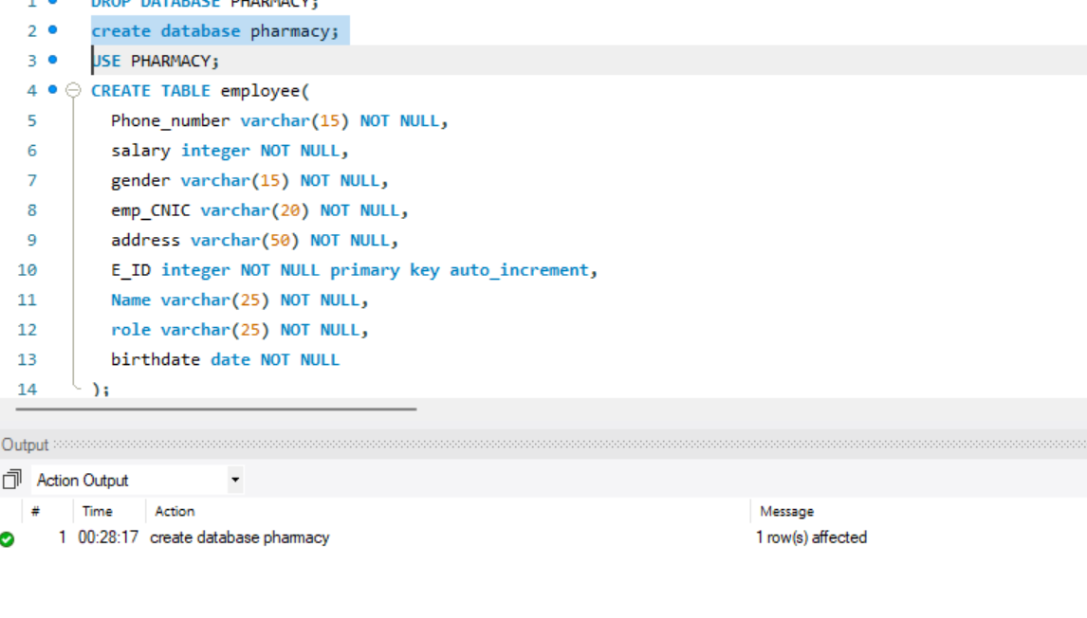
- CREATING ALL TABLES

CREATE TABLE employee(
Phone_number varchar(15) NOT NULL,
salary integer NOT NULL,
gender varchar(15) NOT NULL,
emp_CNIC varchar(20) NOT NULL,
address varchar(50) NOT NULL,
E_ID integer NOT NULL primary key auto_increment,
Name varchar(25) NOT NULL,
role varchar(25) NOT NULL,
birthdate date NOT NULL
);
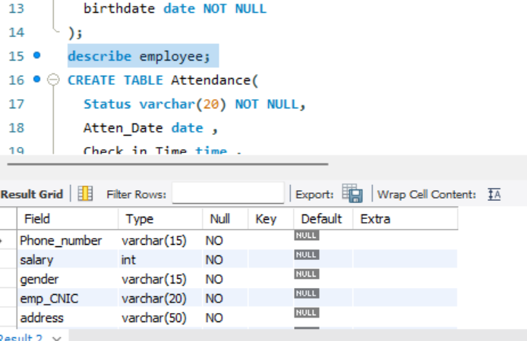

CREATE TABLE Attendance(
Status varchar(20) NOT NULL,
Atten_Date date ,
Check_in_Time time ,
Check_Out_Time time ,
E_ID INT NOT NULL,
FOREIGN KEY (E_ID) REFERENCES employee(E_ID)
on delete cascade
);
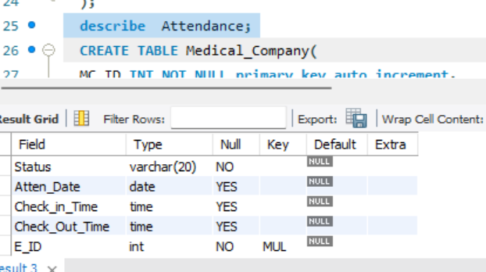

CREATE TABLE Medical_Company(
MC_ID INT NOT NULL primary key auto_increment,
MC_Name varchar(50) NOT NULL,
MC_address varchar(50) NOT NULL,
Contact_Number varchar(15) NOT NULL
);
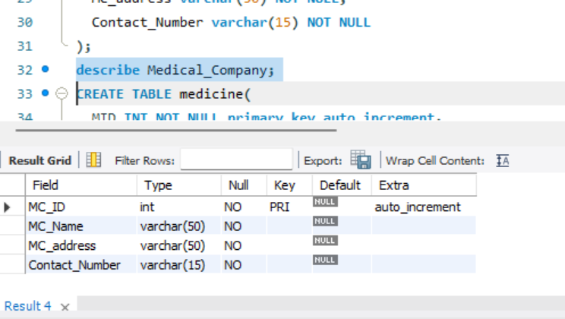
CREATE TABLE medicine(
MID INT NOT NULL primary key auto_increment,
medicine_name varchar(50) NOT NULL ,
MFG_date date NOT NULL,
EXP_date date NOT NULL,
price INT NOT NULL,
E_ID INT ,
MC_ID INT NOT NULL,
quantity INT NOT NULL,
FOREIGN KEY (E_ID) REFERENCES employee(E_ID)
on delete cascade,
foreign key (MC_ID) references medical_company(MC_ID)
on delete cascade
); 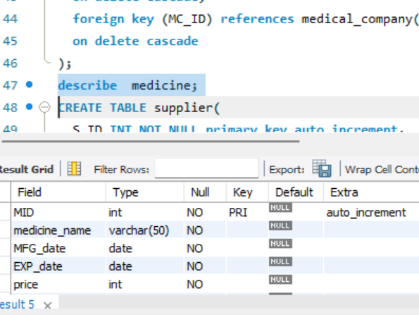

CREATE TABLE supplier(
S_ID INT NOT NULL primary key auto_increment,
name varchar(50) NOT NULL ,
contact_number varchar(15) NOT NULL
);
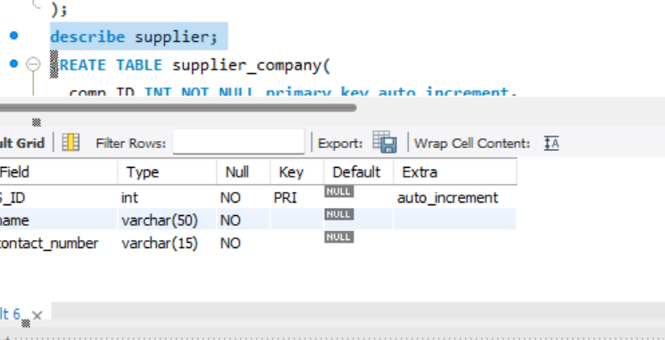
CREATE TABLE supplier_company(
comp_ID INT NOT NULL primary key auto_increment,
comp_name varchar(50) NOT NULL,
comp_address varchar(50) NOT NULL,
Contact_Number varchar(15) NOT NULL
);
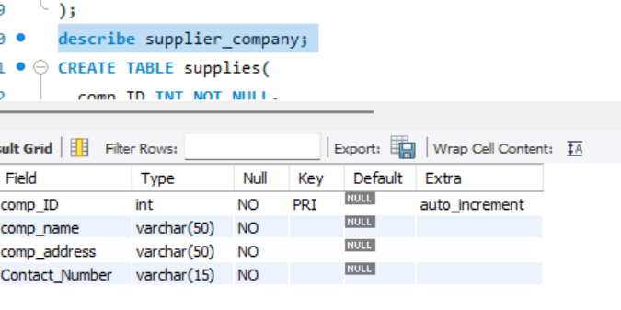
CREATE TABLE supplies(
comp_ID INT NOT NULL,
S_ID INT NOT NULL,
PRIMARY KEY (comp_ID, S_ID),
FOREIGN KEY (comp_ID) REFERENCES supplier_company(comp_ID)
on delete cascade,
FOREIGN KEY (S_ID) REFERENCES supplier(S_ID)
on delete cascade
);
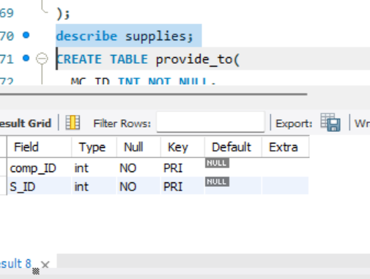
CREATE TABLE provide_to(
MC_ID INT NOT NULL,
comp_ID INT NOT NULL,
PRIMARY KEY (MC_ID, comp_ID),
FOREIGN KEY (MC_ID) REFERENCES Medical_Company(MC_ID)
on delete cascade,
FOREIGN KEY (comp_ID) REFERENCES supplier_company(comp_ID)
on delete cascade
); 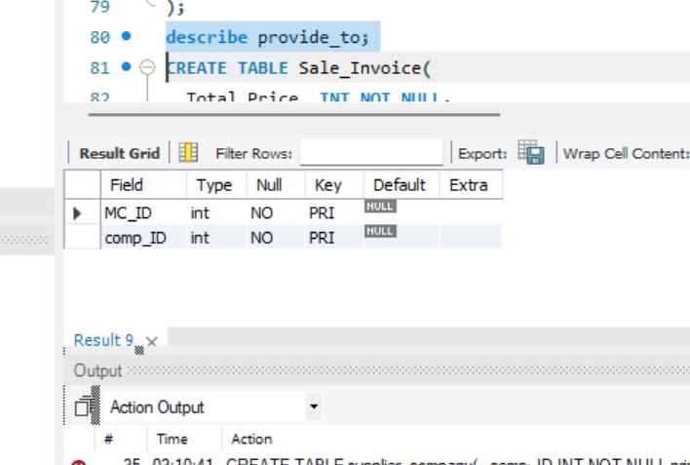
CREATE TABLE Sale_Invoice(
Total_Price_ INT NOT NULL,
Total_Product INT NOT NULL,
Invoice_ID INT NOT NULL primary key auto_increment,
Reference_Number INT NOT NULL,
created_date date not null
);
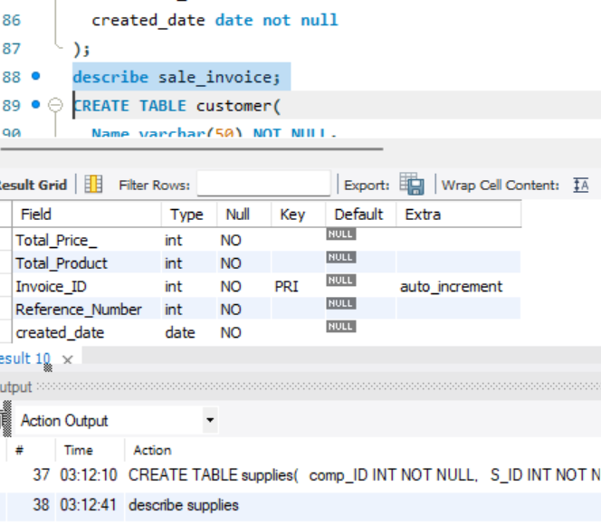
CREATE TABLE customer(
Name varchar(50) NOT NULL,
C_ID INT NOT NULL primary key auto_increment,
phone_number varchar(15) NOT NULL,
Invoice_ID INT NOT NULL,
FOREIGN KEY (Invoice_ID) REFERENCES Sale_Invoice(Invoice_ID)
on delete cascade
);
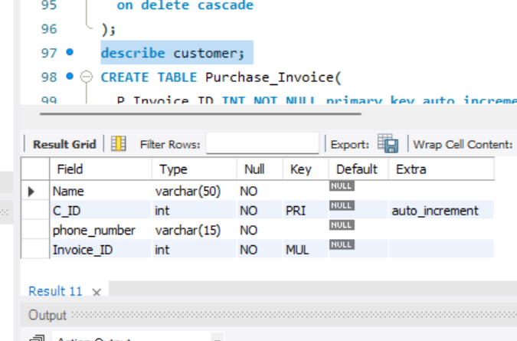
CREATE TABLE Purchase_Invoice(
P_Invoice_ID INT NOT NULL primary key auto_increment,
Medicine_Name varchar(50) NOT NULL,
Expiry_Date date NOT NULL,
Buying_Price INT NOT NULL,
Total_Quantity INT NOT NULL,
Net_Amount INT NOT NULL,
Margin int NOT NULL
);
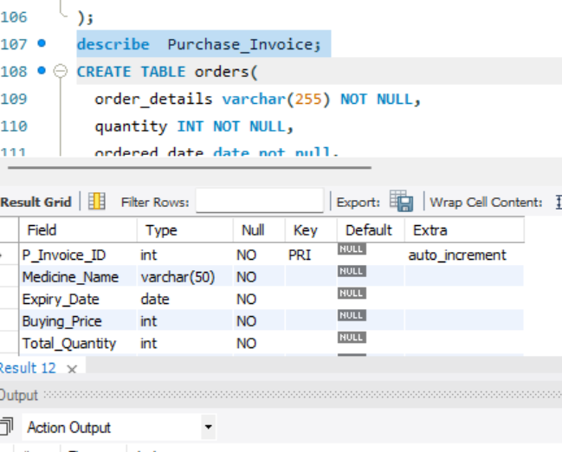
CREATE TABLE orders(
order_details varchar(255) NOT NULL,
quantity INT NOT NULL,
ordered_date date not null,
C_ID INT NOT NULL,
E_ID INT NOT NULL,
PRIMARY KEY (C_ID, E_ID),
FOREIGN KEY (C_ID) REFERENCES customer(C_ID) on delete cascade,
FOREIGN KEY (E_ID) REFERENCES employee(E_ID) on delete cascade
);
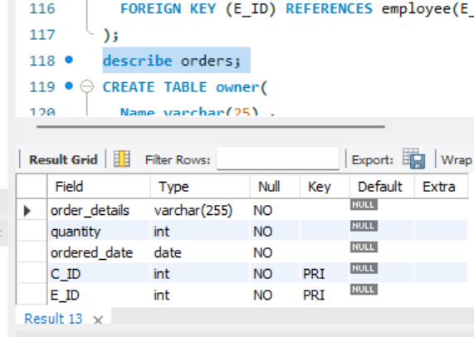
CREATE TABLE owner(
Name varchar(25) ,
E_ID INT ,
S_ID INT ,
P_Invoice_ID INT ,
FOREIGN KEY (E_ID) REFERENCES employee(E_ID) on delete cascade,
FOREIGN KEY (S_ID) REFERENCES supplier(S_ID) on delete cascade,
FOREIGN KEY (P_Invoice_ID) REFERENCES Purchase_Invoice(P_Invoice_ID) on delete cascade
);
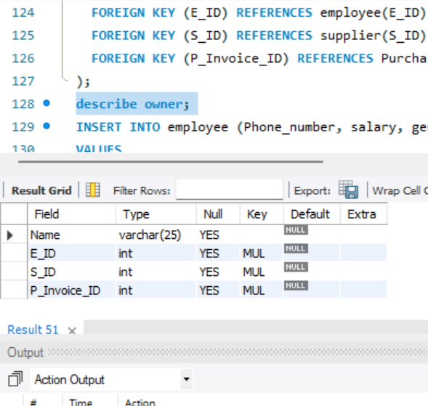
2 . inserting data in tables
INSERT INTO employee (Phone_number, salary, gender, emp_CNIC, address, Name, role, birthdate)
VALUES
('0321-1234567', 50000, 'Male', '12345-1234567-1', '123 Main Street, Lahore', 'Muhammad Ahmed', 'employee', '1990-01-01'),
('0333-9876543', 45000, 'Female', '54321-7654321-2', '456 Elm Street, Karachi', 'Fatima Ali', 'admin', '1992-05-15'),
('0345-6789123', 55000, 'Male', '67890-2468135-3', '789 Oak Street, Islamabad', 'Ahmed Khan', 'employee', '1988-11-30'),
('0312-3456789', 60000, 'Female', '13579-9753108-4', '321 Maple Street, Lahore', 'Sana Ahmed', 'pharmacist', '1995-07-10'),
('0300-8765432', 48000, 'Male', '98765-4321098-5', '654 Pine Street, Karachi', 'Kamran Ali', 'employee', '1991-03-20'),
('0301-6789123', 53000, 'Male', '78901-2345678-9', '852 Maple Avenue, Islamabad', 'Ali Hassan', 'employee', '1992-12-08'),
('0311-8765432', 47000, 'Male', '98765-0987654-3', '963 Cedar Avenue, Karachi', 'Adnan Ahmed', 'employee', '1990-04-25'),
('0332-9876543', 54000, 'Female', '54321-4321098-5', '852 Oak Avenue, Islamabad', 'Zainab Fatima', 'pharmacist', '1993-10-10'),
('0303-1234567', 58000, 'Male', '12345-6543210-7', '741 Maple Avenue, Lahore', 'Rizwan Ali', 'employee', '1988-07-18'),
('0320-4567890', 50000, 'Female', '09876-0987654-9', '963 Elm Street, Karachi', 'Ayesha Khan', 'admin', '1991-01-30'),
('0342-6789123', 56000, 'Male', '78901-3210987-1', '852 Pine Street, Islamabad', 'Bilal Ahmed', 'employee', '1989-08-05'),
('0314-3456789', 62000, 'Female', '13579-6543210-2', '753 Cedar Street, Lahore', 'Hira Khan', 'pharmacist', '1995-02-20'),
('0305-8765432', 46000, 'Male', '98765-0987654-3', '963 Oak Street, Karachi', 'Imran Ali', 'employee', '1992-09-08'),
('0330-1234567', 59000, 'Male', '12345-6543210-7', '741 Elm Street, Lahore', 'Amina Fatima', 'employee', '1990-10-04'),
('0312-4567890', 51000, 'Female', '09876-0987654-9', '963 Pine Street, Karachi', 'Huma Khan', 'pharmacist', '1993-04-17'),
('0344-6789123', 57000, 'Male', '78901-3210987-1', '852 Cedar Street, Islamabad', 'Usman Ahmed', 'employee', '1988-11-30'),
('0313-3456789', 63000, 'Female', '13579-6543210-2', '753 Oak Avenue, Lahore', 'Sadia Ali', 'admin', '1996-07-12'),
('0304-8765432', 45000, 'Male', '98765-0987654-3', '963 Maple Avenue, Karachi', 'Kashif Ali', 'employee', '1991-02-24'),
('0316-1234567', 60000, 'Male', '12345-6543210-7', '741 Pine Avenue, Lahore', 'Asif Ahmed', 'employee', '1989-04-16'),
('0306-6789123', 54000, 'Male', '78901-3210987-1', '852 Oak Avenue, Islamabad', 'Akbar Khan', 'employee', '1994-06-10'),
('0317-8765432', 48000, 'Male', '98765-0987654-3', '963 Elm Street, Karachi', 'Rashid Ali', 'employee', '1990-08-05'),
('0302-1234567', 62000, 'Male', '12345-6543210-7', '741 Cedar Street, Lahore', 'Khalid Ahmed', 'employee', '1991-07-02'),
('0325-4567890', 49000, 'Female', '09876-0987654-9', '963 Oak Street, Karachi', 'Fiza Fatima', 'pharmacist', '1994-11-15'),
('0310-6789123', 56000, 'Male', '78901-3210987-1', '852 Maple Street, Islamabad', 'Abdul Rehman', 'employee', '1988-12-29'),
('0307-8765432', 47000, 'Male', '98765-0987654-3', '963 Pine Avenue, Karachi', 'Kamran Khan', 'employee', '1993-04-26'),
('0315-1234567', 61000, 'Male', '12345-6543210-7', '741 Oak Avenue, Lahore', 'Ahmed Ali', 'employee', '1989-06-21'),
('0303-6789123', 57000, 'Male', '78901-3210987-1', '852 Maple Avenue, Islamabad', 'Farhan Ahmed', 'employee', '1994-05-17'),
('0326-3456789', 63000, 'Female', '13579-6543210-2', '753 Pine Avenue, Lahore', 'Hafsa Fatima', 'pharmacist', '1995-10-31'),
('0311-8765432', 48000, 'Male', '98765-0987654-3', '963 Cedar Avenue, Karachi', 'Saim Ahmed', 'employee', '1990-07-13'),
('0304-1234567', 62000, 'Male', '12345-6543210-7', '741 Maple Avenue, Lahore', 'Noman Ali', 'employee', '1991-06-09'),
('0316-1234567', 60000, 'Male', '12345-6543210-7', '741 Pine Avenue, Lahore', 'Muhammad Ali', 'employee', '1989-04-16'),
('0306-6789123', 54000, 'Male', '78901-3210987-1', '852 Oak Avenue, Islamabad', 'Ahmed Khan', 'employee', '1994-06-10'),
('0317-8765432', 48000, 'Male', '98765-0987654-3', '963 Elm Street, Karachi', 'Fatima Ahmed', 'employee', '1990-08-05'),
('0302-1234567', 62000, 'Male', '12345-6543210-7', '741 Cedar Street, Lahore', 'Aisha Siddiqui', 'employee', '1991-07-02'),
('0325-4567890', 49000, 'Female', '09876-0987654-9', '963 Oak Street, Karachi', 'Sana Malik', 'pharmacist', '1994-11-15'),
('0310-6789123', 56000, 'Male', '78901-3210987-1', '852 Maple Street, Islamabad', 'Hassan Raza', 'employee', '1988-12-29'),
('0307-8765432', 47000, 'Male', '98765-0987654-3', '963 Pine Avenue, Karachi', 'Nadia Khan', 'employee', '1993-04-26'),
('0315-1234567', 61000, 'Male', '12345-6543210-7', '741 Oak Avenue, Lahore', 'Abdul Rehman', 'employee', '1989-06-21'),
('0303-6789123', 57000, 'Male', '78901-3210987-1', '852 Maple Avenue, Islamabad', 'Saira Mahmood', 'employee', '1994-05-17'),
('0326-3456789', 63000, 'Female', '13579-6543210-2', '753 Pine Avenue, Lahore', 'Farah Ahmed', 'pharmacist', '1995-10-31'),
('0311-8765432', 48000, 'Male', '98765-0987654-3', '963 Cedar Avenue, Karachi', 'Saeed Hassan', 'employee', '1990-07-13'),
('0304-1234567', 62000, 'Male', '12345-6543210-7', '741 Maple Avenue, Lahore', 'Fariha Ali', 'employee', '1991-06-09'),
('0327-4567890', 49000, 'Female', '09876-0987654-9', '963 Elm Street, Karachi', 'Sadia Shahid', 'pharmacist', '1994-10-22'),
('0312-6789123', 58000, 'Male', '78901-3210987-1', '852 Pine Street, Islamabad', 'Tariq Mahmood', 'employee', '1988-08-04'),
('0335-3456789', 64000, 'Female', '13579-6543210-2', '753 Cedar Street, Lahore', 'Samina Khan', 'admin', '1996-01-17'),
('0306-8765432', 46000, 'Male', '98765-0987654-3', '963 Oak Street, Karachi', 'Aliya Ahmed', 'employee', '1993-06-01'),
('0325-9876543', 55000, 'Female', '54321-4321098-5', '852 Maple Street, Islamabad', 'Zara Khan', 'pharmacist', '1992-01-14'),
('0313-1234567', 63000, 'Male', '12345-6543210-7', '741 Elm Street, Lahore', 'Kamran Ali', 'employee', '1990-08-27'),
('0314-8765432', 47000, 'Male', '98765-0987654-3', '963 Maple Avenue, Karachi', 'Amna Khan', 'employee', '1992-12-20'),
('0337-9876543', 56000, 'Female', '54321-4321098-5', '852 Elm Avenue, Islamabad', 'Ayesha Malik', 'admin', '1994-07-03'),
('0307-1234567', 64000, 'Male', '12345-6543210-7', '741 Pine Avenue, Lahore', 'Mohammad Hassan', 'employee', '1991-02-15');
INSERT INTO Attendance (Status, Atten_Date, Check_in_Time, Check_Out_Time, E_ID)
VALUES
('present', '2023-06-01', '09:00:00', '18:00:00', 1),
('present', '2023-06-01', '09:30:00', '18:30:00', 2),
('present', '2023-06-01', '09:15:00', '18:15:00', 3),
('present', '2023-06-01', '09:10:00', '18:10:00', 4),
('present', '2023-06-01', '09:20:00', '18:20:00', 5),
('present', '2023-06-02', '09:00:00', '18:00:00', 6),
('present', '2023-06-02', '09:30:00', '18:30:00', 7),
('present', '2023-06-02', '09:15:00', '18:15:00', 8),
('present', '2023-06-02', '09:10:00', '18:10:00', 9),
('present', '2023-06-02', '09:20:00', '18:20:00', 10),
('present', '2023-06-03', '09:00:00', '18:00:00', 11),
('present', '2023-06-03', '09:30:00', '18:30:00', 12),
('present', '2023-06-03', '09:15:00', '18:15:00', 13),
('present', '2023-06-03', '09:10:00', '18:10:00', 14),
('present', '2023-06-03', '09:20:00', '18:20:00', 15),
('present', '2023-06-07', '09:15:00', '18:15:00', 33),
('absent', '2023-06-07', NULL, NULL, 34),
('leave', '2023-06-07', NULL, NULL, 35),
('absent', '2023-06-08', NULL, NULL, 36),
('absent', '2023-06-08', NULL, NULL, 37),
('present', '2023-06-08', '09:15:00', '18:15:00', 38),
('leave', '2023-06-08', NULL, NULL, 39),
('present', '2023-06-08', '09:20:00', '18:20:00', 40),
('absent', '2023-06-09', NULL, NULL, 41),
('present', '2023-06-09', '09:30:00', '18:30:00', 42),
('present', '2023-06-09', '09:15:00', '18:15:00', 43),
('leave', '2023-06-09', NULL, NULL, 44),
('present', '2023-06-09', '09:20:00', '18:20:00', 45),
('absent', '2023-06-10', NULL, NULL, 46),
('absent', '2023-06-10', NULL, NULL, 47),
('present', '2023-06-10', '09:15:00', '18:15:00', 48),
('leave', '2023-06-10', NULL, NULL, 49),
('present', '2023-06-10', '09:20:00', '18:20:00', 50),
('present', '2023-06-11', '09:00:00', '18:00:00', 32),
('absent', '2023-06-11', NULL, NULL, 42),
('present', '2023-06-11', '09:15:00', '18:15:00', 33),
('leave', '2023-06-11', NULL, NULL, 24),
('present', '2023-06-11', '09:20:00', '18:20:00', 45),
('absent', '2023-06-12', NULL, NULL, 16),
('present', '2023-06-12', '09:30:00', '18:30:00', 27),
('absent', '2023-06-12', NULL, NULL, 38),
('leave', '2023-06-12', NULL, NULL, 49),
('present', '2023-06-12', '09:20:00', '18:20:00', 30),
('absent', '2023-06-13', NULL, NULL, 21),
('present', '2023-06-13', '09:30:00', '18:30:00', 12),
('present', '2023-06-13', '09:15:00', '18:15:00', 13),
('leave', '2023-06-13', NULL, NULL, 34),
('present', '2023-06-13', '09:20:00', '18:20:00', 45),
('absent', '2023-06-14', NULL, NULL, 46),
('absent', '2023-06-14', NULL, NULL, 37),
('present', '2023-06-14', '09:15:00', '18:15:00', 18),
('leave', '2023-06-14', NULL, NULL, 19),
('present', '2023-06-14', '09:20:00', '18:20:00', 20),
('absent', '2023-06-15', NULL, NULL, 21),
('present', '2023-06-15', '09:30:00', '18:30:00', 22),
('present', '2023-06-15', '09:15:00', '18:15:00', 35),
('present', '2023-06-04', '09:00:00', '18:00:00', 16),
('present', '2023-06-04', '09:30:00', '18:30:00', 17),
('present', '2023-06-04', '09:15:00', '18:15:00', 18),
('present', '2023-06-04', '09:10:00', '18:10:00', 19),
('present', '2023-06-04', '09:20:00', '18:20:00', 20),
('present', '2023-06-05', '09:00:00', '18:00:00', 21),
('present', '2023-06-05', '09:30:00', '18:30:00', 22),
('present', '2023-06-05', '09:15:00', '18:15:00', 23),
('present', '2023-06-05', '09:10:00', '18:10:00', 24),
('present', '2023-06-05', '09:20:00', '18:20:00', 25),
('present', '2023-06-06', '09:00:00', '18:00:00', 26),
('present', '2023-06-06', '09:30:00', '18:30:00', 27),
('present', '2023-06-06', '09:15:00', '18:15:00', 28),
('present', '2023-06-06', '09:10:00', '18:10:00', 29),
('present', '2023-06-06', '09:20:00', '18:20:00', 30),
('present', '2023-06-07', '09:00:00', '18:00:00', 31),
('present', '2023-06-07', '09:30:00', '18:30:00', 32),
('present', '2023-06-07', '09:15:00', '18:15:00', 33),
('present', '2023-06-07', '09:10:00', '18:10:00', 34),
('present', '2023-06-07', '09:20:00', '18:20:00', 35),
('present', '2023-06-08', '09:00:00', '18:00:00', 36),
('present', '2023-06-08', '09:30:00', '18:30:00', 37),
('present', '2023-06-08', '09:15:00', '18:15:00', 38),
('present', '2023-06-08', '09:10:00', '18:10:00', 39),
('present', '2023-06-08', '09:20:00', '18:20:00', 40),
('present', '2023-06-09', '09:00:00', '18:00:00', 41),
('present', '2023-06-09', '09:30:00', '18:30:00', 42),
('present', '2023-06-09', '09:15:00', '18:15:00', 43),
('present', '2023-06-09', '09:10:00', '18:10:00', 44),
('present', '2023-06-09', '09:20:00', '18:20:00', 45),
('present', '2023-06-10', '09:00:00', '18:00:00', 46),
('present', '2023-06-10', '09:30:00', '18:30:00', 47),
('present', '2023-06-10', '09:15:00', '18:15:00', 48),
('present', '2023-06-10', '09:10:00', '18:10:00', 49),
('present', '2023-06-10', '09:20:00', '18:20:00', 50),
('present', '2023-06-01', '09:00:00', '18:00:00', 1),
('absent', '2023-06-01', NULL, NULL, 2),
('present', '2023-06-01', '09:15:00', '18:15:00', 3),
('leave', '2023-06-01', NULL, NULL, 4),
('present', '2023-06-01', '09:20:00', '18:20:00', 5),
('absent', '2023-06-02', NULL, NULL, 6),
('present', '2023-06-02', '09:30:00', '18:30:00', 7),
('absent', '2023-06-02', NULL, NULL, 8),
('leave', '2023-06-02', NULL, NULL, 9),
('present', '2023-06-02', '09:20:00', '18:20:00', 10),
('absent', '2023-06-03', NULL, NULL, 11),
('present', '2023-06-03', '09:30:00', '18:30:00', 12),
('present', '2023-06-03', '09:15:00', '18:15:00', 13),
('leave', '2023-06-03', NULL, NULL, 14),
('present', '2023-06-03', '09:20:00', '18:20:00', 15),
('absent', '2023-06-04', NULL, NULL, 16),
('absent', '2023-06-04', NULL, NULL, 17),
('present', '2023-06-04', '09:15:00', '18:15:00', 18),
('leave', '2023-06-04', NULL, NULL, 19),
('present', '2023-06-04', '09:20:00', '18:20:00', 20),
('absent', '2023-06-05', NULL, NULL, 21),
('present', '2023-06-05', '09:30:00', '18:30:00', 22),
('present', '2023-06-05', '09:15:00', '18:15:00', 23),
('leave', '2023-06-05', NULL, NULL, 24),
('absent', '2023-06-05', NULL, NULL, 25),
('absent', '2023-06-06', NULL, NULL, 26),
('present', '2023-06-06', '09:30:00', '18:30:00', 27),
('absent', '2023-06-06', NULL, NULL, 28),
('absent', '2023-06-06', NULL, NULL, 29),
('present', '2023-06-06', '09:20:00', '18:20:00', 30),
('absent', '2023-06-07', NULL, NULL, 31),
('present', '2023-06-07', '09:30:00', '18:30:00', 32),
('present', '2023-06-16', '09:00:00', '18:00:00', 41),
('absent', '2023-06-16', NULL, NULL, 32),
('present', '2023-06-16', '09:15:00', '18:15:00', 43),
('leave', '2023-06-16', NULL, NULL, 44),
('present', '2023-06-16', '09:20:00', '18:20:00', 35),
('absent', '2023-06-17', NULL, NULL, 36),
('present', '2023-06-17', '09:30:00', '18:30:00', 17),
('absent', '2023-06-17', NULL, NULL, 8),
('leave', '2023-06-17', NULL, NULL, 9),
('present', '2023-06-17', '09:20:00', '18:20:00', 10),
('absent', '2023-06-18', NULL, NULL, 1),
('present', '2023-06-18', '09:30:00', '18:30:00', 2),
('present', '2023-06-18', '09:15:00', '18:15:00', 3),
('leave', '2023-06-18', NULL, NULL, 4),
('present', '2023-06-18', '09:20:00', '18:20:00', 5),
('absent', '2023-06-19', NULL, NULL, 6),
('absent', '2023-06-19', NULL, NULL, 27),
('present', '2023-06-19', '09:15:00', '18:15:00', 8),
('leave', '2023-06-19', NULL, NULL, 9),
('present', '2023-06-19', '09:20:00', '18:20:00', 30),
('absent', '2023-06-20', NULL, NULL, 11),
('present', '2023-06-20', '09:30:00', '18:30:00', 42),
('present', '2023-06-20', '09:15:00', '18:15:00', 10),
('absent', '2023-06-21', NULL, NULL, 41),
('present', '2023-06-21', '09:00:00', '18:00:00', 2),
('leave', '2023-06-21', NULL, NULL, 13),
('present', '2023-06-21', '09:15:00', '18:15:00', 4),
('absent', '2023-06-21', NULL, NULL, 5),
('present', '2023-06-22', '09:30:00', '18:30:00', 6),
('absent', '2023-06-22', NULL, NULL, 7),
('leave', '2023-06-22', NULL, NULL, 8),
('present', '2023-06-22', '09:20:00', '18:20:00', 9),
('absent', '2023-06-23', NULL, NULL, 10),
('present', '2023-06-23', '09:30:00', '18:30:00', 31),
('present', '2023-06-23', '09:15:00', '18:15:00', 42),
('leave', '2023-06-23', NULL, NULL, 13),
('present', '2023-06-23', '09:20:00', '18:20:00', 34),
('absent', '2023-06-24', NULL, NULL, 5),
('absent', '2023-06-24', NULL, NULL, 6),
('present', '2023-06-24', '09:15:00', '18:15:00', 7),
('leave', '2023-06-24', NULL, NULL, 8),
('present', '2023-06-24', '09:20:00', '18:20:00', 9),
('absent', '2023-06-25', NULL, NULL, 40),
('present', '2023-06-25', '09:30:00', '18:30:00', 31),
('present', '2023-06-25', '09:15:00', '18:15:00', 22),
('leave', '2023-06-25', NULL, NULL, 46),
('present', '2023-06-01', '09:00:00', '18:00:00', 1),
('absent', '2023-06-01', NULL, NULL, 2),
('present', '2023-06-01', '09:15:00', '18:15:00', 3),
('leave', '2023-06-01', NULL, NULL, 4),
('present', '2023-06-01', '09:20:00', '18:20:00', 5),
('absent', '2023-06-02', NULL, NULL, 6),
('present', '2023-06-02', '09:30:00', '18:30:00', 7),
('absent', '2023-06-02', NULL, NULL, 8),
('leave', '2023-06-02', NULL, NULL, 9),
('present', '2023-06-02', '09:20:00', '18:20:00', 10),
('absent', '2023-06-03', NULL, NULL, 11),
('present', '2023-06-03', '09:30:00', '18:30:00', 12),
('present', '2023-06-03', '09:15:00', '18:15:00', 13),
('leave', '2023-06-03', NULL, NULL, 14),
('present', '2023-06-03', '09:20:00', '18:20:00', 15),
('absent', '2023-06-04', NULL, NULL, 16),
('absent', '2023-06-04', NULL, NULL, 17),
('present', '2023-06-04', '09:15:00', '18:15:00', 18),
('leave', '2023-06-04', NULL, NULL, 19),
('present', '2023-06-04', '09:20:00', '18:20:00', 20),
('absent', '2023-06-05', NULL, NULL, 21),
('present', '2023-06-05', '09:30:00', '18:30:00', 22),
('present', '2023-06-05', '09:15:00', '18:15:00', 23),
('leave', '2023-06-05', NULL, NULL, 24),
('present', '2023-06-05', '09:20:00', '18:20:00', 25),
('absent', '2023-06-06', NULL, NULL, 26),
('present', '2023-06-06', '09:30:00', '18:30:00', 27),
('absent', '2023-06-06', NULL, NULL, 28),
('leave', '2023-06-06', NULL, NULL, 29),
('present', '2023-06-06', '09:20:00', '18:20:00', 30),
('absent', '2023-06-07', NULL, NULL, 31),
('present', '2023-06-07', '09:30:00', '18:30:00', 32),
('present', '2023-06-07', '09:15:00', '18:15:00', 33),
('leave', '2023-06-07', NULL, NULL, 34),
('present', '2023-06-07', '09:20:00', '18:20:00', 35),
('absent', '2023-06-08', NULL, NULL, 36),
('absent', '2023-06-08', NULL, NULL, 37),
('present', '2023-06-08', '09:15:00', '18:15:00', 38),
('leave', '2023-06-08', NULL, NULL, 39),
('present', '2023-06-08', '09:20:00', '18:20:00', 40),
('absent', '2023-06-09', NULL, NULL, 41),
('present', '2023-06-09', '09:30:00', '18:30:00', 42),
('present', '2023-06-09', '09:15:00', '18:15:00', 43),
('leave', '2023-06-09', NULL, NULL, 44),
('present', '2023-06-09', '09:20:00', '18:20:00', 45),
('absent', '2023-06-10', NULL, NULL, 46),
('present', '2023-06-10', '09:30:00', '18:30:00', 47),
('absent', '2023-06-10', NULL, NULL, 48),
('leave', '2023-06-10', NULL, NULL, 49),
('present', '2023-06-10', '09:20:00', '18:20:00', 50);

INSERT INTO Medical_Company (MC_Name, MC_address, Contact_Number)
VALUES
('MedicoPharma', '123 Main Street, Lahore, Pakistan', '0123456789'),
('LifeCure Pharmaceuticals', '456 Market Avenue, Karachi, Pakistan', '9876543210'),
('HealthyMeds', '789 Hospital Road, Islamabad, Pakistan', '0234567891'),
('MediGen', '321 Medical Complex, Lahore, Pakistan', '9123456780'),
('Carewell Drugs', '567 Health Plaza, Karachi, Pakistan', '0987654321'),
('PharmaVital', '901 Medicine Street, Lahore, Pakistan', '2345678901'),
('HealFirst Pharmaceuticals', '345 Cure Avenue, Islamabad, Pakistan', '8901234567'),
('WellnessMeds', '678 Health Center, Karachi, Pakistan', '7654321098'),
('PakPharm', '012 Pharmacy Road, Lahore, Pakistan', '9012345678'),
('MediCare Solutions', '234 Medical Tower, Islamabad, Pakistan', '6789012345'),
('GlobalHealth', '567 Health Avenue, Karachi, Pakistan', '4567890123'),
('MediLink Pharmaceuticals', '890 Health Complex, Lahore, Pakistan', '7890123456'),
('CureWell', '123 Medication Street, Islamabad, Pakistan', '5678901234'),
('PharmaSolutions', '456 Health Plaza, Karachi, Pakistan', '3456789012'),
('MediExpress', '789 Cure Avenue, Lahore, Pakistan', '2345678901'),
('LifeCure Pharmaceuticals', '012 Medical Center, Islamabad, Pakistan', '8901234567'),
('HealthMeds', '234 Medication Road, Karachi, Pakistan', '6789012345'),
('CarePharma', '567 Pharmacy Avenue, Lahore, Pakistan', '4567890123'),
('MediWise', '890 Health Street, Islamabad, Pakistan', '3456789012'),
('WellnessPlus', '012 Cure Complex, Karachi, Pakistan', '2345678901'),
('PharmaGen', '234 Health Tower, Lahore, Pakistan', '7890123456'),
('MediCare Solutions', '567 Medical Avenue, Islamabad, Pakistan', '0123456789'),
('GlobalCure Pharmaceuticals', '890 Cure Road, Karachi, Pakistan', '9012345678'),
('MediHealth', '123 Health Center, Lahore, Pakistan', '6789012345'),
('PharmaVital', '456 Medicine Street, Islamabad, Pakistan', '3456789012'),
('CurePharma', '789 Medication Plaza, Karachi, Pakistan', '2345678901'),
('MediLink Pharmaceuticals', '012 Medical Complex, Lahore, Pakistan', '7890123456'),
('HealthyMeds', '234 Health Avenue, Islamabad, Pakistan', '5678901234'),
('WellnessCure', '567 Cure Tower, Karachi, Pakistan', '4567890123'),
('MediExpress', '890 Health Plaza, Lahore, Pakistan', '3456789012'),
('LifeCure Pharmaceuticals', '012 Health Road, Islamabad, Pakistan', '2345678901'),
('PharmaSolutions', '234 Pharmacy Avenue, Karachi, Pakistan', '7890123456'),
('MediWise', '567 Medication Center, Lahore, Pakistan', '0123456789'),
('HealthCare Pharma', '890 Health Street, Islamabad, Pakistan', '9012345678'),
('CureWell', '123 Cure Complex, Karachi, Pakistan', '6789012345'),
('MediPharm', '456 Medical Tower, Lahore, Pakistan', '3456789012'),
('GlobalHealth', '789 Health Avenue, Islamabad, Pakistan', '2345678901'),
('CarePharma', '012 Pharmacy Road, Karachi, Pakistan', '7890123456'),
('MediGen', '234 Medical Plaza, Lahore, Pakistan', '5678901234'),
('WellnessPlus', '567 Health Center, Islamabad, Pakistan', '4567890123'),
('PakPharm', '890 Pharmacy Avenue, Karachi, Pakistan', '3456789012'),
('MediHealth', '012 Health Complex, Lahore, Pakistan', '2345678901'),
('PharmaVital', '234 Medicine Street, Islamabad, Pakistan', '7890123456'),
('MediLink Pharmaceuticals', '567 Health Plaza, Karachi, Pakistan', '9012345678'),
('HealthyMeds', '890 Hospital Road, Lahore, Pakistan', '6789012345'),
('WellnessCure', '123 Cure Avenue, Islamabad, Pakistan', '5678901234'),
('MediExpress', '456 Medical Center, Karachi, Pakistan', '4567890123'),
('LifeCure Pharmaceuticals', '789 Market Avenue, Lahore, Pakistan', '3456789012'),
('MediGen', '234 Medical Plaza, Lahore, Pakistan', '5678901234'),
('ABCPharm', '890 Pharmacy Avenue, Karachi, Pakistan', '3045789012'),
('ABCHealth', '012 Health Complex, Lahore, Pakistan', '3145678901');

INSERT INTO medicine (medicine_name, MFG_date, EXP_date, price, E_ID, MC_ID, quantity)
VALUES
('Panadol', '2023-06-26', '2024-06-26', 6, 12, 45, 100),
('Amoxicillin', '2023-06-01', '2024-06-01', 10, NULL, 1, 100),
('Ciprofloxacin', '2023-06-01', '2024-06-01', 8, 2, 2, 150),
('Paracetamol', '2023-06-02', '2024-06-02', 5, 3, 3, 200),
('Ibuprofen', '2023-06-02', '2024-06-02', 6, NULL, 4, 120),
('Aspirin', '2023-06-03', '2024-06-03', 4, 5, 5, 180),
('Loratadine', '2023-06-03', '2024-06-03', 7, NULL, 6, 90),
('Omeprazole', '2023-06-04', '2024-06-04', 9, 6, 7, 250),
('Simvastatin', '2023-06-04', '2024-06-04', 12, NULL, 8, 80),
('Metformin', '2023-06-05', '2024-06-05', 3, NULL, 9, 300),
('Lisinopril', '2023-06-05', '2024-06-05', 6, 8, 10, 150),
('Losartan', '2023-06-06', '2024-06-06', 8, NULL, 11, 120),
('Atorvastatin', '2023-06-06', '2024-06-06', 10, 9, 12, 100),
('Metoprolol', '2023-06-07', '2024-06-07', 5, NULL, 13, 200),
('Amlodipine', '2023-06-07', '2024-06-07', 7, 10, 14, 150),
('Warfarin', '2023-06-08', '2024-06-08', 6, NULL, 15, 180),
('Digoxin', '2023-06-08', '2024-06-08', 9, 11, 16, 100),
('Levothyroxine', '2023-06-09', '2024-06-09', 4, NULL, 17, 300),
('Prednisone', '2023-06-09', '2024-06-09', 5, 12, 18, 250),
('Albuterol', '2023-06-10', '2024-06-10', 3, NULL, 19, 400),
('Insulin', '2023-06-10', '2024-06-10', 12, 13, 20, 150),
('Cetirizine', '2023-06-11', '2024-06-11', 7, NULL, 21, 120),
('Ciprofloxacin', '2023-06-11', '2024-06-11', 15, 14, 22, 70),
('Gabapentin', '2023-06-12', '2024-06-12', 8, NULL, 23, 200),
('Tramadol', '2023-06-12', '2024-06-12', 6, 15, 24, 150),
('Zolpidem', '2023-06-13', '2024-06-13', 9, NULL, 25, 100),
('Morphine', '2023-06-13', '2024-06-13', 12, 16, 26, 120),
('Codeine', '2023-06-14', '2024-06-14', 7, NULL, 27, 180),
('Ranitidine', '2023-06-14', '2024-06-14', 5, 17, 28, 90),
('Furosemide', '2023-06-15', '2024-06-15', 10, NULL, 29, 250),
('Citalopram', '2023-06-15', '2024-06-15', 6, 18, 30, 80),
('Ibuprofen', '2023-06-16', '2024-06-16', 6, NULL, 31, 120),
('Aspirin', '2023-06-16', '2024-06-16', 4, 19, 32, 180),
('Loratadine', '2023-06-17', '2024-06-17', 7, NULL, 33, 90),
('Omeprazole', '2023-06-17', '2024-06-17', 9, 20, 34, 250),
('Simvastatin', '2023-06-18', '2024-06-18', 12, NULL, 35, 80),
('Metformin', '2023-06-18', '2024-06-18', 3, NULL, 36, 300),
('Lisinopril', '2023-06-19', '2024-06-19', 6, 21, 37, 150),
('Losartan', '2023-06-19', '2024-06-19', 8, NULL, 38, 120),
('Atorvastatin', '2023-06-20', '2024-06-20', 10, 22, 39, 100),
('Metoprolol', '2023-06-20', '2024-06-20', 5, NULL, 40, 200),
('Amlodipine', '2023-06-21', '2024-06-21', 7, 23, 41, 150),
('Warfarin', '2023-06-21', '2024-06-21', 6, NULL, 42, 180),
('Digoxin', '2023-06-22', '2024-06-22', 9, 24, 43, 100),
('Levothyroxine', '2023-06-22', '2024-06-22', 4, NULL, 44, 300),
('Prednisone', '2023-06-23', '2024-06-23', 5, 25, 45, 250),
('Albuterol', '2023-06-23', '2024-06-23', 3, NULL, 46, 400),
('Insulin', '2023-06-24', '2024-06-24', 12, 26, 47, 150),
('Cetirizine', '2023-06-24', '2024-06-24', 7, NULL, 48, 120),
('Ciprofloxacin', '2023-06-25', '2024-06-25', 15, 27, 49, 70),
('Gabapentin', '2023-06-25', '2024-06-25', 8, NULL, 50, 200);

INSERT INTO supplier (name, contact_number) VALUES
('Ali Traders', '0312-1234567'),
('Khan Enterprises', '0345-9876543'),
('Ahmed Pharma', '0300-5555555'),
('Raza Medicals', '0321-2468135'),
('Saeed Distributors', '0333-7778889'),
('Hassan Suppliers', '0346-2345678'),
('Mehmood Pharmacy', '0311-9876543'),
('Rashid Healthcare', '0322-4567890'),
('Ayesha Pharma', '0345-1112223'),
('Farhan Traders', '0303-8765432'),
('Sami Distributors', '0315-5432109'),
('Nasir Pharmacy', '0320-2345678'),
('Imran Medicals', '0331-9876543'),
('Kamran Enterprises', '0346-5555555'),
('Zubair Suppliers', '0300-2468135'),
('Irfan Traders', '0312-7778889'),
('Nadeem Pharma', '0321-2345678'),
('Omar Healthcare', '0333-8765432'),
('Sohail Distributors', '0345-1112223'),
('Sara Pharmacy', '0306-9876543'),
('Adnan Medicals', '0313-8765432'),
('Aamir Enterprises', '0344-5432109'),
('Salman Pharma', '0309-2345678'),
('Waqar Traders', '0311-9876543'),
('Faisal Distributors', '0322-5555555'),
('Usman Pharmacy', '0330-2468135'),
('Khalid Medicals', '0341-7778889'),
('Zahid Suppliers', '0303-2345678'),
('Qaiser Pharma', '0312-8765432'),
('Sajjad Healthcare', '0321-1112223'),
('Tariq Traders', '0345-9876543'),
('Asif Distributors', '0300-5555555'),
('Imtiaz Pharmacy', '0315-2468135'),
('Rizwan Medicals', '0320-7778889'),
('Ahmad Enterprises', '0331-2345678'),
('Noman Pharma', '0342-8765432'),
('Kashif Healthcare', '0306-1112223'),
('Sami Traders', '0313-9876543'),
('Yousuf Suppliers', '0322-5555555'),
('Asad Pharma', '0335-2468135'),
('Ali Medicals', '0344-7778889'),
('Shoaib Pharmacy', '0303-2345678'),
('Mubarak Distributors', '0311-8765432'),
('Raheel Enterprises', '0324-1112223'),
('Sohail Traders', '0345-9876543'),
('Aslam Pharma', '0300-5555555'),
('Saeed Healthcare', '0315-2468135'),
('Tahir Suppliers', '0322-7778889'),
('Qasim Pharma', '0333-2345678'),
('Shakeel Medicals', '0342-8765432');

INSERT INTO supplier_company (comp_name, comp_address, Contact_Number) VALUES
('ABC Pharmaceuticals', '123 Street, Karachi', '0312-1234567'),
('XYZ Healthcare', '456 Road, Lahore', '0321-9876543'),
('MediPlus', '789 Avenue, Islamabad', '0345-5678901'),
('HealthSolutions', '321 Lane, Rawalpindi', '0300-8765432'),
('CurePharma', '987 Boulevard, Faisalabad', '0333-2345678'),
('PharmaCare', '654 Park, Multan', '0322-8765432'),
('MediLife', '876 Plaza, Peshawar', '0311-1234567'),
('WellnessMeds', '234 Market, Quetta', '0344-9876543'),
('Healthera', '567 Mall, Hyderabad', '0335-5678901'),
('PharmaPro', '321 Complex, Abbottabad', '0301-8765432'),
('MediMart', '987 Tower, Sialkot', '0323-2345678'),
('Safeway Pharmaceuticals', '654 Building, Gujranwala', '0312-8765432'),
('LifeCure', '123 Arcade, Bahawalpur', '0343-9876543'),
('HealthPlus', '456 Plaza, Sukkur', '0332-5678901'),
('PharmaLink', '789 Mall, Larkana', '0300-8765432'),
('MediHealth', '321 Complex, Rahim Yar Khan', '0321-2345678'),
('CureMed', '987 Center, Nawabshah', '0313-8765432'),
('HealthyLife', '654 Avenue, Mirpur Khas', '0342-9876543'),
('PharmaWell', '876 Street, Muzaffarabad', '0331-5678901'),
('MediPharm', '234 Market, Skardu', '0301-8765432'),
('HealthCare', '567 Road, Gilgit', '0324-2345678'),
('WellnessPharma', '321 Lane, Chitral', '0311-8765432'),
('HealMeds', '987 Plaza, Swat', '0345-9876543'),
('MediPro', '654 Market, Murree', '0334-5678901'),
('CurePlus', '123 Complex, Attock', '0300-8765432'),
('PharmaLife', '456 Tower, Taxila', '0322-2345678'),
('LifeLink', '789 Arcade, Wah Cantt', '0312-8765432'),
('HealthMart', '321 Mall, Jhelum', '0343-9876543'),
('PharmaHealth', '987 Center, Gujar Khan', '0332-5678901'),
('MediSolutions', '654 Plaza, Rawat', '0301-8765432'),
('SafeMeds', '876 Building, Kotli', '0324-2345678'),
('LifeCare', '234 Road, Bagh', '0311-8765432'),
('HealthPro', '567 Market, Mirpur', '0345-9876543'),
('PharmaCure', '321 Complex, Muzaffarabad', '0334-5678901'),
('MediWell', '987 Tower, Skardu', '0300-8765432'),
('WellnessCare', '654 Street, Gilgit', '0323-2345678'),
('HealPharma', '123 Plaza, Chitral', '0312-8765432'),
('PharmaMed', '456 Market, Swat', '0343-9876543'),
('HealthyMeds', '789 Mall, Murree', '0332-5678901'),
('MediPlus', '321 Lane, Attock', '0301-8765432'),
('CureHealth', '987 Avenue, Taxila', '0322-2345678'),
('LifePharma', '654 Park, Wah Cantt', '0313-8765432'),
('HealthPlus', '876 Plaza, Jhelum', '0345-9876543'),
('PharmaLink', '234 Market, Gujar Khan', '0334-5678901'),
('MediHealth', '567 Mall, Rawat', '0300-8765432'),
('CureMed', '321 Complex, Kotli', '0321-2345678'),
('WellnessLife', '987 Center, Bagh', '0311-8765432'),
('HealWell', '654 Avenue, Mirpur', '0342-9876543'),
('PharmaPro', '876 Street, Muzaffarabad', '0331-5678901'),
('MediLink', '789 Arcade, Islamabad', '0344-5678901'),
('HealthCare Solutions', '987 Boulevard, Karachi', '0321-9876543');

INSERT INTO provide_to (MC_ID, comp_ID) VALUES
(1, 1),
(2, 2),
(3, 3),
(4, 4),
(5, 5),
(6, 6),
(7, 7),
(8, 8),
(9, 9),
(10, 10),
(11, 11),
(12, 12),
(13, 13),
(14, 14),
(15, 15),
(16, 16),
(17, 17),
(18, 18),
(19, 19),
(20, 20),
(21, 21),
(22, 22),
(23, 23),
(24, 24),
(25, 25),
(26, 26),
(27, 27),
(28, 28),
(29, 29),
(30, 30),
(31, 31),
(32, 32),
(33, 33),
(34, 34),
(35, 35),
(36, 36),
(37, 37),
(38, 38),
(39, 39),
(40, 40),
(41, 41),
(42, 42),
(43, 43),
(44, 44),
(45, 45),
(46, 46),
(47, 47),
(48, 48),
(49, 49),
(50, 50);

INSERT INTO supplies (S_ID, comp_ID) VALUES
(1, 1),
(2, 2),
(3, 3),
(4, 4),
(5, 5),
(6, 6),
(7, 7),
(8, 8),
(9, 9),
(10, 10),
(11, 11),
(12, 12),
(13, 13),
(14, 14),
(15, 15),
(16, 16),
(17, 17),
(18, 18),
(19, 19),
(20, 20),
(21, 21),
(22, 22),
(23, 23),
(24, 24),
(25, 25),
(26, 26),
(27, 27),
(28, 28),
(29, 29),
(30, 30),
(31, 31),
(32, 32),
(33, 33),
(34, 34),
(35, 35),
(36, 36),
(37, 37),
(38, 38),
(39, 39),
(40, 40),
(41, 41),
(42, 42),
(43, 43),
(44, 44),
(45, 45),
(46, 46),
(47, 47),
(48, 48),
(49, 49),
(50, 50);

INSERT INTO Purchase_Invoice (Medicine_Name, Expiry_Date, Buying_Price, Total_Quantity, Net_Amount, Margin)
SELECT medicine_name, EXP_date, price, quantity, price * quantity, (price * quantity * 0.1)
FROM medicine;

INSERT INTO owner (Name,S_ID,P_Invoice_ID,E_ID) VALUES
("Zain",1, 1,1),
("Zain",2, 2,2),
("Zain",3, 3,3),
("Zain",4, 4,4),
("Zain",5, 5,5),
("Zain",6, 6,6),
("Zain",7, 7,7),
("Zain",8, 8,9),
("Zain",9, 9,8),
("Zain",10, 10,10),
("Zain",11, 11,11),
("Zain",12, 12,12),
("Zain",13, 13,13),
("Zain",14, 14,14),
("Zain",15, 15,15),
("Zain",16, 16,16),
("Zain",17, 17,17),
("Zain",18, 18,18),
("Zain",19, 19,19),
("Zain",20, 20,20),
("Zain",21, 21,21),
("Zain",22, 22,22),
("Zain",23, 23,23),
("Zain",24, 24,24),
("Zain",25, 25,25),
("Zain",26, 26,26),
("Zain",27, 27,27),
("Zain",28, 28,28),
("Zain",29, 29,29),
("Zain",30, 30,30),
("Zain",31, 31,31),
("Zain",32, 32,32),
("Zain",33, 33,33),
("Zain",34, 34,34),
("Zain",35, 35,35),
("Zain",36, 36,36),
("Zain",37, 37,37),
("Zain",38, 38,38),
("Zain",39, 39,39),
("Zain",40, 40,40),
("Zain",41, 41,41),
("Zain",42, 42,42),
("Zain",43, 43,43),
("Zain",44, 44,44),
("Zain",45, 45,45),
("Zain",46, 46,46),
("Zain",47, 47,47),
("Zain",48, 48,48),
("Zain",49, 49,49),
("Zain",50, 50,50);

INSERT INTO Sale_Invoice (Total_Price_, Total_Product, Reference_Number, created_date)
VALUES
(100, 5, 1, '2023-06-01'),
(200, 8, 2, '2023-06-02'),
(150, 6, 3, '2023-06-03'),
(120, 4, 4, '2023-06-04'),
(180, 7, 5, '2023-06-05'),
(250, 9, 6, '2023-06-06'),
(160, 5, 7, '2023-06-07'),
(220, 8, 8, '2023-06-08'),
(190, 6, 9, '2023-06-09'),
(140, 4, 10, '2023-06-10'),
(170, 7, 11, '2023-06-11'),
(230, 9, 12, '2023-06-12'),
(180, 5, 13, '2023-06-13'),
(200, 8, 14, '2023-06-14'),
(160, 6, 15, '2023-06-15'),
(140, 4, 16, '2023-06-16'),
(250, 7, 17, '2023-06-17'),
(210, 9, 18, '2023-06-18'),
(170, 5, 19, '2023-06-19'),
(190, 8, 20, '2023-06-20'),
(220, 6, 21, '2023-06-21'),
(130, 4, 22, '2023-06-22'),
(150, 7, 23, '2023-06-23'),
(200, 9, 24, '2023-06-24'),
(170, 5, 25, '2023-06-25'),
(180, 8, 26, '2023-06-26'),
(140, 6, 27, '2023-06-27'),
(210, 4, 28, '2023-06-28'),
(230, 7, 29, '2023-06-29'),
(160, 9, 30, '2023-06-30'),
(150, 5, 31, '2023-07-01'),
(190, 8, 32, '2023-07-02'),
(220, 6, 33, '2023-07-03'),
(180, 4, 34, '2023-07-04'),
(170, 7, 35, '2023-07-05'),
(130, 9, 36, '2023-07-06'),
(160, 5, 37, '2023-07-07'),
(200, 8, 38, '2023-07-08'),
(150, 6, 39, '2023-07-09'),
(170, 4, 40, '2023-07-10'),
(190, 7, 41, '2023-07-11'),
(210, 9, 42, '2023-07-12'),
(140, 5, 43, '2023-07-13'),
(180, 8, 44, '2023-07-14'),
(220, 6, 45, '2023-07-15'),
(160, 4, 46, '2023-07-16'),
(130, 7, 47, '2023-07-17'),
(170, 9, 48, '2023-07-18'),
(190, 5, 49, '2023-07-19'),
(150, 8, 50, '2023-07-20');

INSERT INTO customer (Name, phone_number, Invoice_ID) VALUES
('Muhammad Ahmed', '+92XXXXXXXXXX', 1),
('Fatima Ali', '+92XXXXXXXXXX', 2),
('Ali Khan', '+92XXXXXXXXXX', 3),
('Sara Ahmed', '+92XXXXXXXXXX', 4),
('Abdullah Raza', '+92XXXXXXXXXX', 5),
('Zainab Malik', '+92XXXXXXXXXX', 6),
('Hassan Mahmood', '+92XXXXXXXXXX', 7),
('Ayesha Qureshi', '+92XXXXXXXXXX', 8),
('Ahmed Khan', '+92XXXXXXXXXX', 9),
('Zara Siddiqui', '+92XXXXXXXXXX', 10),
('Asad Ali', '+92XXXXXXXXXX', 11),
('Amna Malik', '+92XXXXXXXXXX', 12),
('Hamza Raza', '+92XXXXXXXXXX', 13),
('Aisha Mahmood', '+92XXXXXXXXXX', 14),
('Kamran Qureshi', '+92XXXXXXXXXX', 15),
('Rabia Khan', '+92XXXXXXXXXX', 16),
('Usman Siddiqui', '+92XXXXXXXXXX', 17),
('Mehwish Ali', '+92XXXXXXXXXX', 18),
('Yasir Raza', '+92XXXXXXXXXX', 19),
('Sadia Khan', '+92XXXXXXXXXX', 20),
('Ali Haider', '+92XXXXXXXXXX', 21),
('Nida Qureshi', '+92XXXXXXXXXX', 22),
('Bilal Ahmed', '+92XXXXXXXXXX', 23),
('Sana Malik', '+92XXXXXXXXXX', 24),
('Imran Raza', '+92XXXXXXXXXX', 25),
('Samina Mahmood', '+92XXXXXXXXXX', 26),
('Farhan Qureshi', '+92XXXXXXXXXX', 27),
('Hina Khan', '+92XXXXXXXXXX', 28),
('Rizwan Siddiqui', '+92XXXXXXXXXX', 29),
('Nimra Ali', '+92XXXXXXXXXX', 30),
('Khalid Raza', '+92XXXXXXXXXX', 31),
('Fiza Malik', '+92XXXXXXXXXX', 32),
('Waqar Ahmed', '+92XXXXXXXXXX', 33),
('Madiha Khan', '+92XXXXXXXXXX', 34),
('Omar Siddiqui', '+92XXXXXXXXXX', 35),
('Naila Ali', '+92XXXXXXXXXX', 36),
('Saad Raza', '+92XXXXXXXXXX', 37),
('Amina Mahmood', '+92XXXXXXXXXX', 38),
('Fahad Qureshi', '+92XXXXXXXXXX', 39),
('Anam Khan', '+92XXXXXXXXXX', 40),
('Kamran Haider', '+92XXXXXXXXXX', 41),
('Nazia Qureshi', '+92XXXXXXXXXX', 42),
('Usama Ahmed', '+92XXXXXXXXXX', 43),
('Sara Malik', '+92XXXXXXXXXX', 44),
('Owais Raza', '+92XXXXXXXXXX', 45),
('Hira Siddiqui', '+92XXXXXXXXXX', 46),
('Ahmed Ali', '+92XXXXXXXXXX', 47),
('Huma Raza', '+92XXXXXXXXXX', 48),
('Asad Mahmood', '+92XXXXXXXXXX', 49),
('Maria Qureshi', '+92XXXXXXXXXX', 50);

INSERT INTO orders (order_details, quantity, ordered_date, C_ID, E_ID)
VALUES
('Paracetamol', 2, '2023-06-01', 1, 1),
('Ibuprofen', 3, '2023-06-02', 2, 1),
('Amoxicillin', 1, '2023-06-03', 3, 2),
('Ciprofloxacin', 2, '2023-06-04', 4, 2),
('Lisinopril', 3, '2023-06-05', 5, 3),
('Atorvastatin', 1, '2023-06-06', 6, 3),
('Metformin', 2, '2023-06-07', 7, 4),
('Omeprazole', 3, '2023-06-08', 8, 4),
('Losartan', 1, '2023-06-09', 9, 5),
('Simvastatin', 2, '2023-06-10', 10, 5),
('Azithromycin', 3, '2023-06-11', 11, 6),
('Prednisone', 1, '2023-06-12', 12, 6),
('Escitalopram', 2, '2023-06-13', 13, 7),
('Sertraline', 3, '2023-06-14', 14, 7),
('Alprazolam', 1, '2023-06-15', 15, 8),
('Gabapentin', 2, '2023-06-16', 16, 8),
('Amlodipine', 3, '2023-06-17', 17, 9),
('Metoprolol', 1, '2023-06-18', 18, 9),
('Hydrochlorothiazide', 2, '2023-06-19', 19, 10),
('Levothyroxine', 3, '2023-06-20', 20, 10),
('Metronidazole', 1, '2023-06-21', 21, 11),
('Furosemide', 2, '2023-06-22', 22, 11),
('Fluoxetine', 3, '2023-06-23', 23, 12),
('Trazodone', 1, '2023-06-24', 24, 12),
('Venlafaxine', 2, '2023-06-25', 25, 13),
('Lorazepam', 3, '2023-06-26', 26, 13),
('Clonazepam', 1, '2023-06-27', 27, 14),
('Metoprolol', 2, '2023-06-28', 28, 14),
('Oxycodone', 3, '2023-06-29', 29, 15),
('Tramadol', 1, '2023-06-30', 30, 15),
('Naproxen', 2, '2023-07-01', 31, 16),
('Warfarin', 3, '2023-07-02', 32, 16),
('Duloxetine', 1, '2023-07-03', 33, 17),
('Carvedilol', 2, '2023-07-04', 34, 17),
('Citalopram', 3, '2023-07-05', 35, 18),
('Meloxicam', 1, '2023-07-06', 36, 18),
('Cyclobenzaprine', 2, '2023-07-07', 37, 19),
('Tamsulosin', 3, '2023-07-08', 38, 19),
('Sulfamethoxazole', 1, '2023-07-09', 39, 20),
('Trimethoprim', 2, '2023-07-10', 40, 20),
('Lansoprazole', 3, '2023-07-11', 41, 21),
('Panadol', 1, '2023-07-12', 42, 21),
('Ranitidine', 2, '2023-07-13', 43, 22),
('Doxycycline', 3, '2023-07-14', 44, 22),
('Clindamycin', 1, '2023-07-15', 45, 23),
('Amoxicillin', 2, '2023-07-16', 46, 23),
('Methocarbamol', 3, '2023-07-17', 47, 24),
('Acetaminophen', 1, '2023-07-18', 48, 24),
('Ibuprofen', 2, '2023-07-19', 49, 25),
('Naproxen', 3, '2023-07-20', 50, 25);

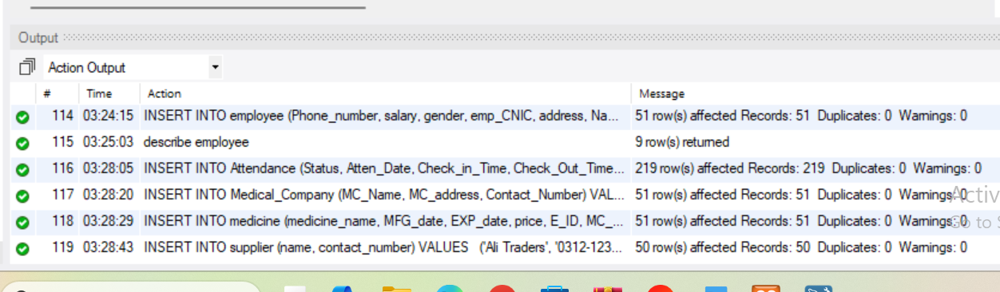
SIMPLE QUERIES
1.
GET ALL MEDICINES WITH QUANTITY LESS THAN 100
SELECT* FROM MEDICINE WHERE QUANTITY < 100;
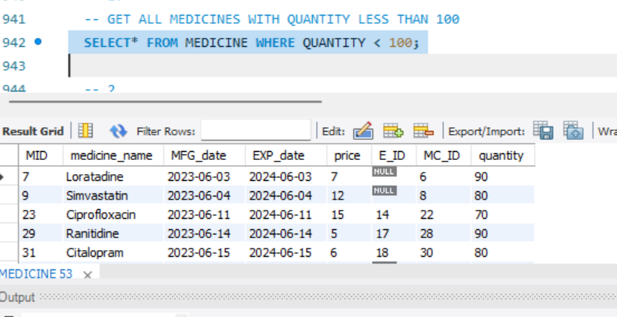

2
LIST ALL PHARMACISTS WITH THEIR BIRTHDATE AND CONTACT INFO
SELECT NAME, PHONE_NUMBER, BIRTHDATE, ADDRESS FROM EMPLOYEE WHERE ROLE = 'PHARMACIST';
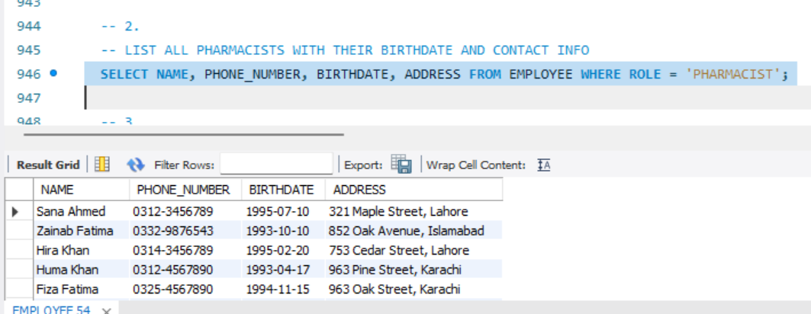

3.
SHOW ALL MEDICINES THAT ARE ABOUT TO EXPIRE WITHIN NEXT TWO MONTHS
SELECT MEDICINE_NAME, EXP_DATE FROM MEDICINE WHERE EXP_DATE <= '2024-08-31' ORDER BY EXP_DATE;
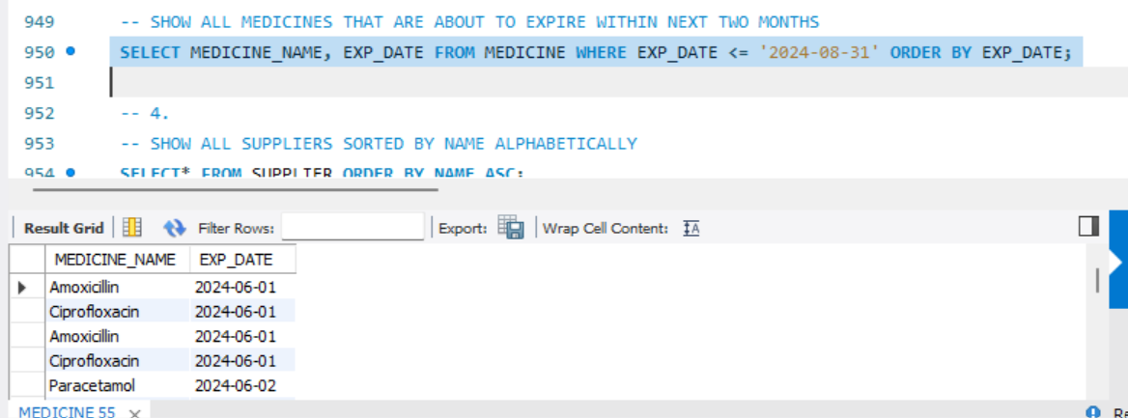
4.
SHOW ALL SUPPLIERS SORTED BY NAME ALPHABETICALLY
SELECT* FROM SUPPLIER ORDER BY NAME ASC;
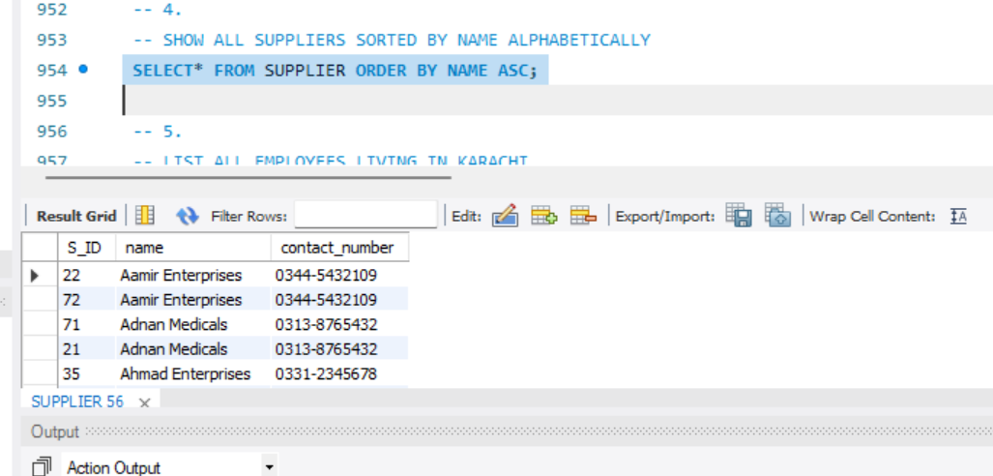 5.
LIST ALL EMPLOYEES LIVING IN KARACHI
SELECT NAME, ADDRESS FROM EMPLOYEE WHERE ADDRESS LIKE '%KARACHI%';
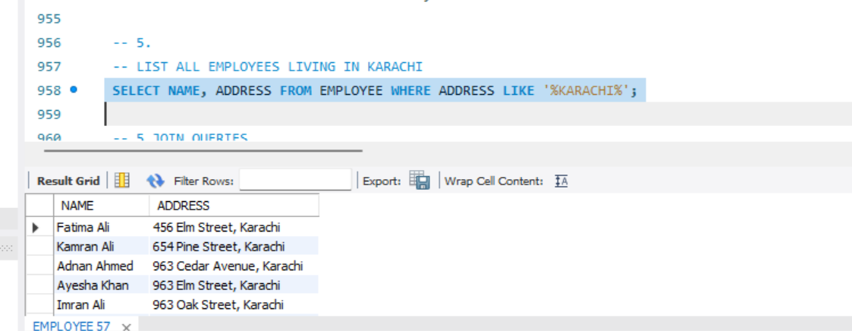

5 JOIN QUERIES
1.
DISPLAY CUSTOMER NAMES ALONG WITH THE TOTAL PRICE OF THEIR INVOICES
SELECT C.NAME, S.TOTAL_PRICE_ FROM CUSTOMER C JOIN SALE_INVOICE S ON C.INVOICE_ID = S.INVOICE_ID;
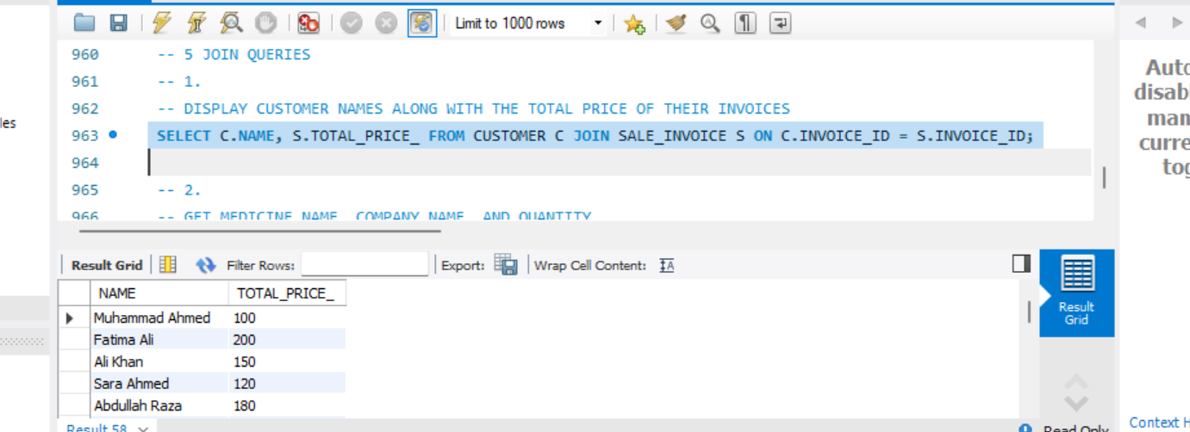
2.
GET MEDICINE NAME, COMPANY NAME, AND QUANTITY
SELECT M.MEDICINE_NAME, C.MC_NAME, M.QUANTITY FROM MEDICINE M JOIN MEDICAL_COMPANY C ON M.MC_ID = C.MC_ID;
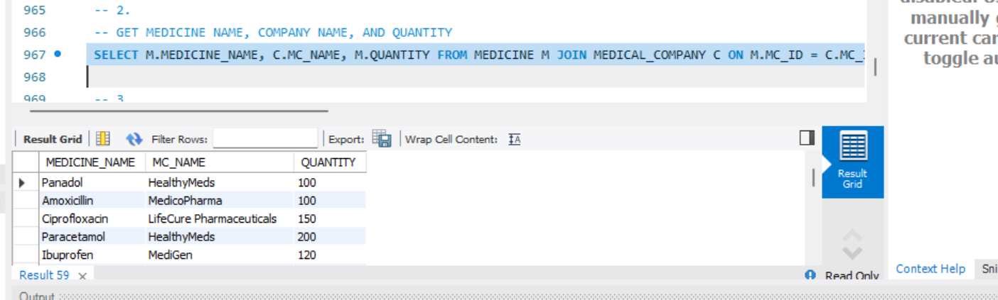

3.
SHOW CUSTOMERS, THE EMPLOYEE WHO HANDLED THEIR ORDER, AND THE ORDER DETAIL
SELECT C.NAME AS CUSTOMER, E.NAME AS EMPLOYEE, O.ORDER_DETAILS FROM ORDERS O JOIN CUSTOMER C ON O.C_ID = C.C_ID
JOIN EMPLOYEE E ON O.E_ID = E.E_ID; 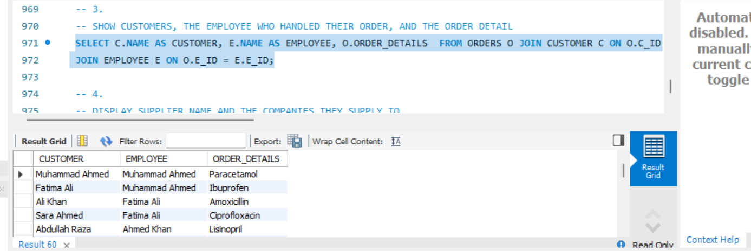

4.
DISPLAY SUPPLIER NAME AND THE COMPANIES THEY SUPPLY TO
SELECT S.NAME AS SUPPLIER, C.COMP_NAME AS COMPANY FROM SUPPLIES SP JOIN SUPPLIER S ON SP.S_ID = S.S_ID
JOIN SUPPLIER_COMPANY C ON SP.COMP_ID = C.COMP_ID;
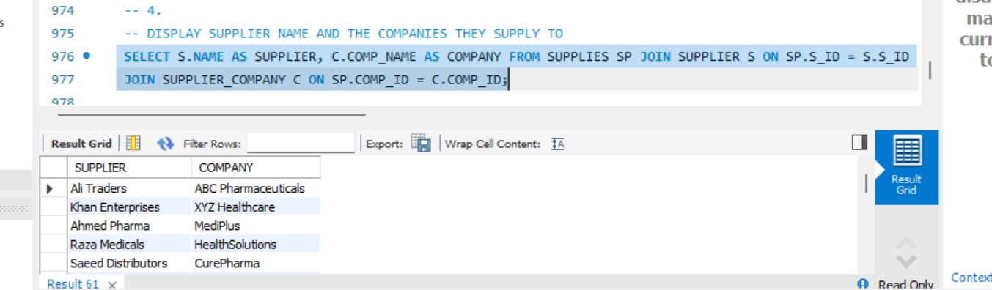

5.
LIST EACH MEDICINE WITH THE NAME OF THE EMPLOYEE WHO ENTERED IT
SELECT M.MEDICINE_NAME, E.NAME AS ENTERED_BY FROM MEDICINE M LEFT JOIN EMPLOYEE E ON M.E_ID = E.E_ID;
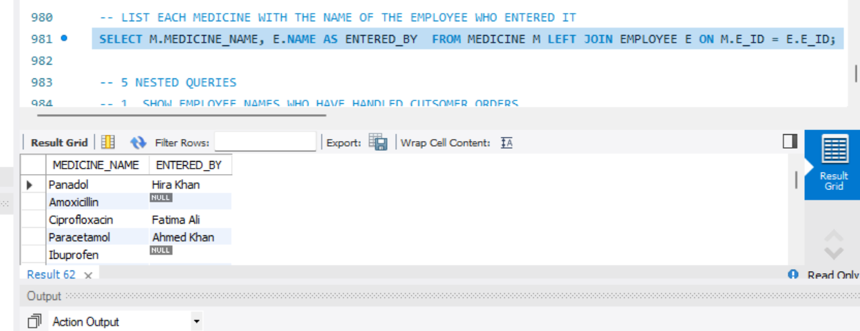

5 NESTED QUERIES
1. SHOW EMPLOYEE NAMES WHO HAVE HANDLED CUTSOMER ORDERS
SELECT NAME FROM EMPLOYEE WHERE E_ID IN ( SELECT DISTINCT E_ID FROM ORDERS);
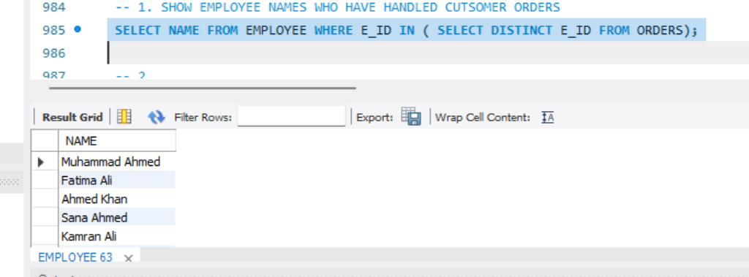

2.
LIST MEDICINES THAT BELONG TO COMPANIES LOCATED IN LAHORE
SELECT MEDICINE_NAME FROM MEDICINE WHERE MC_ID IN (SELECT MC_ID FROM MEDICAL_COMPANY WHERE MC_ADDRESS LIKE '%LAHORE%');
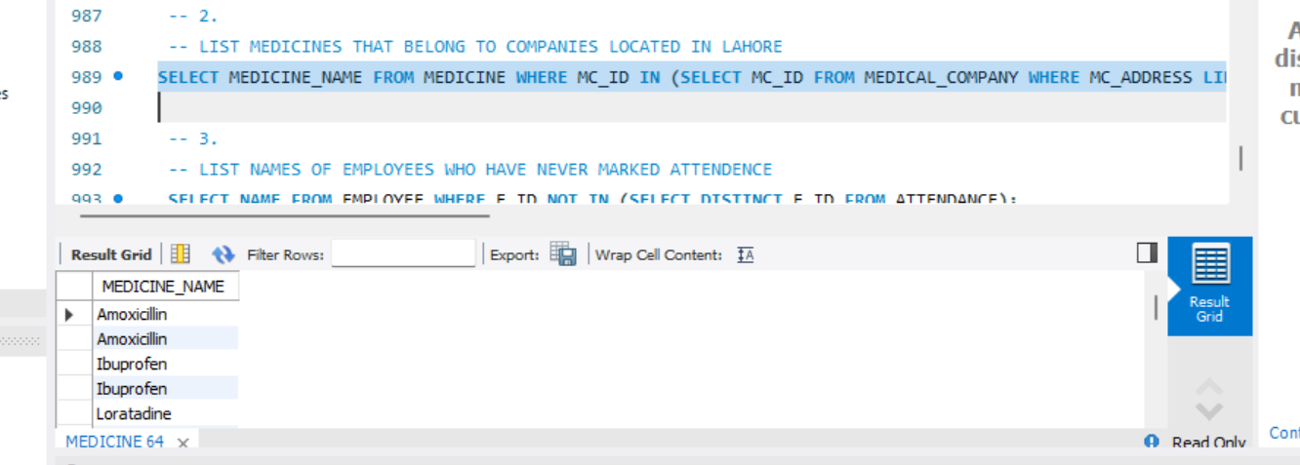

3.
LIST NAMES OF EMPLOYEES WHO HAVE NEVER MARKED ATTENDENCE
SELECT NAME FROM EMPLOYEE WHERE E_ID NOT IN (SELECT DISTINCT E_ID FROM ATTENDANCE);
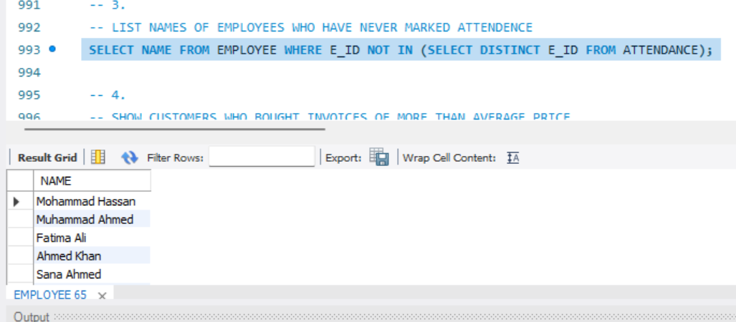

4.
SHOW CUSTOMERS WHO BOUGHT INVOICES OF MORE THAN AVERAGE PRICE
SELECT NAME FROM CUSTOMER WHERE INVOICE_ID IN (SELECT INVOICE_ID FROM SALE_INVOICE WHERE TOTAL_PRICE_ > (SELECT AVG(TOTAL_PRICE_)
FROM SALE_INVOICE));
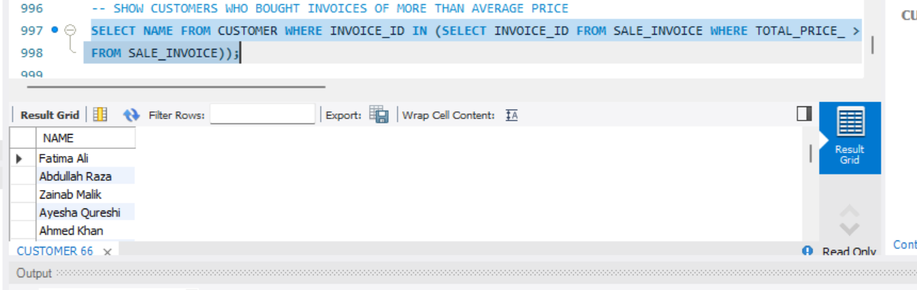

5.
SHOW EMPLOYEES WHO ORDERED MORE THAN 2 ITEMS IN A SINGLE ORDER (CORRELATED SUBQUERY)
SELECT NAME FROM EMPLOYEE E WHERE EXISTS (SELECT* FROM ORDERS O WHERE O.E_ID = E.E_ID AND O.QUANTITY > 2);
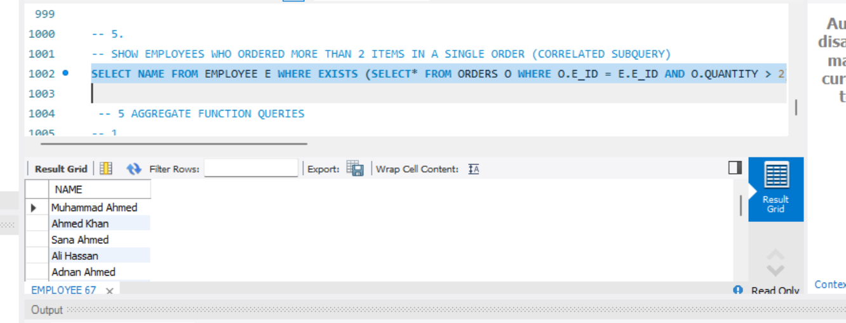

AGGREGATE FUNCTION QUERIES
1.
TOTAL NUMBER OF EMPLOYEES BY GENDER
SELECT GENDER, COUNT(*) AS TOTAL FROM EMPLOYEE GROUP BY GENDER;
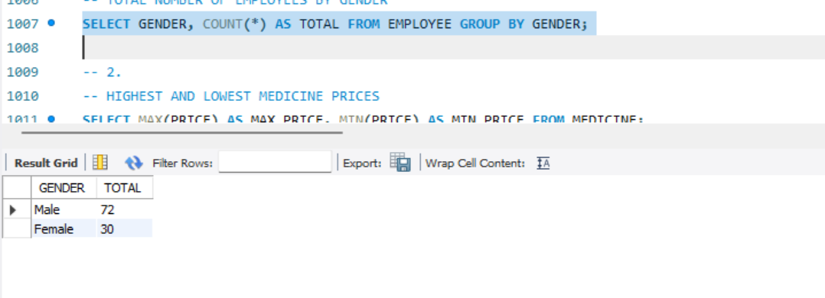
2.
HIGHEST AND LOWEST MEDICINE PRICES
SELECT MAX(PRICE) AS MAX_PRICE, MIN(PRICE) AS MIN_PRICE FROM MEDICINE;
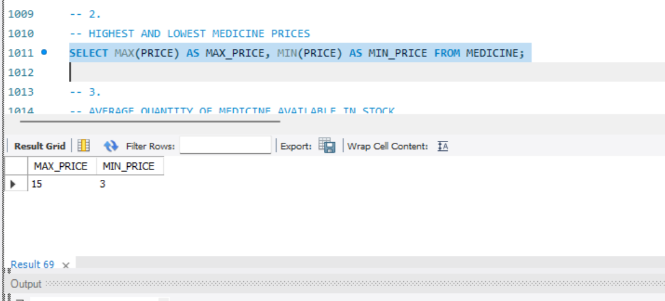
3.
AVERAGE QUANTITY OF MEDICINE AVAILABLE IN STOCK
SELECT AVG(QUANTITY) AS AVG_QUANTITY FROM MEDICINE;
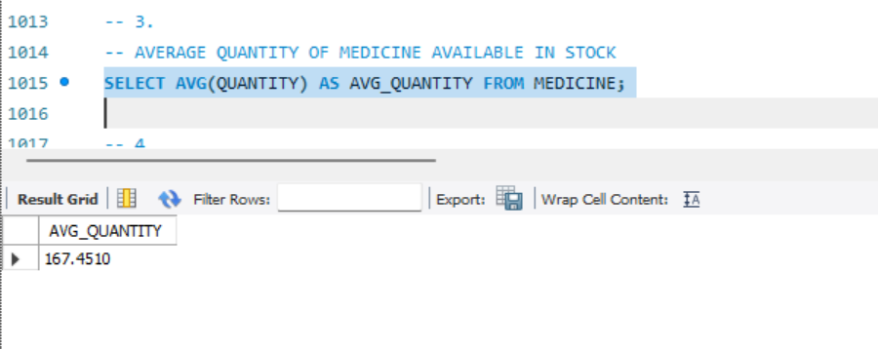
4.
TOTAL SALES VALUE
SELECT SUM(TOTAL_PRICE_) AS TOTAL_SALES FROM SALE_INVOICE;
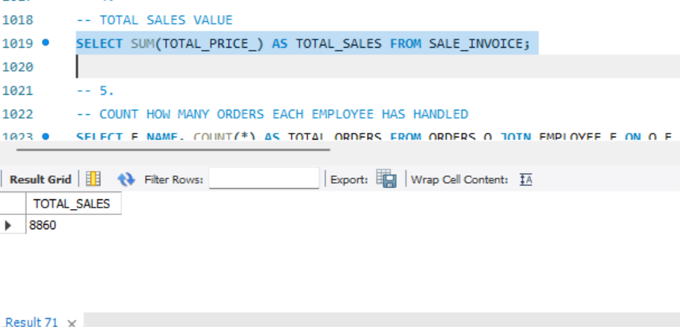
5.
COUNT HOW MANY ORDERS EACH EMPLOYEE HAS HANDLED
SELECT E.NAME, COUNT(*) AS TOTAL_ORDERS FROM ORDERS O JOIN EMPLOYEE E ON O.E_ID = E.E_ID GROUP BY E.NAME;
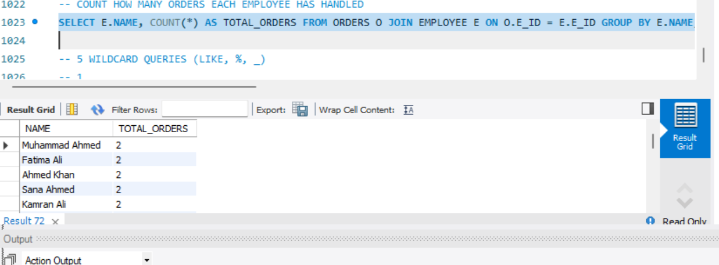
WILDCARD QUERIES (LIKE, %, _)
1.
SHOW ALL MEDICINE NAMES THAT CONTAIN 'MOL'
SELECT * FROM MEDICINE WHERE MEDICINE_NAME LIKE '%MOL%';
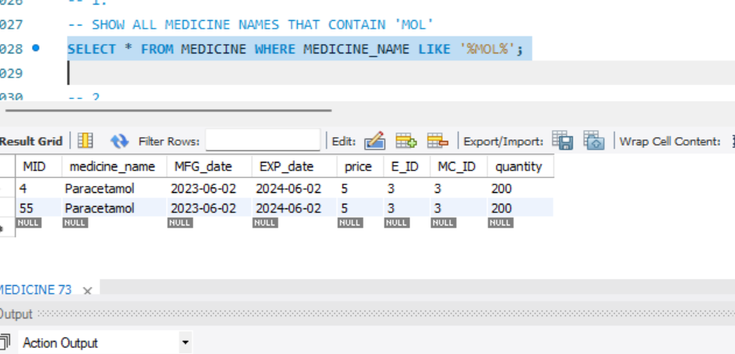
2.
FIND EMPLOYEES WHOSE NAME STARTS WITH 'A'
SELECT * FROM EMPLOYEE WHERE N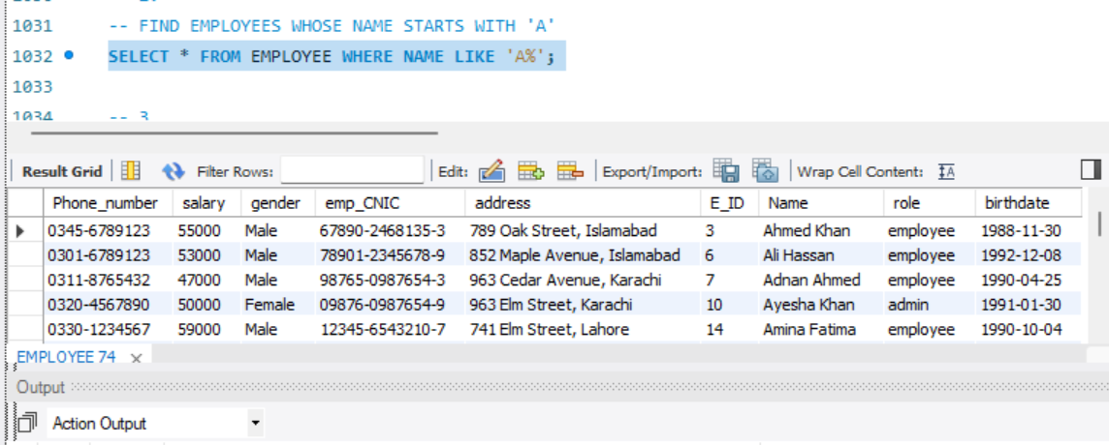AME LIKE 'A%';

3.
FIND CUSTOMERS WHOSE NAME ENDS WITH 'ALI'
SELECT * FROM CUSTOMER WHERE NAME LIKE '%ALI';
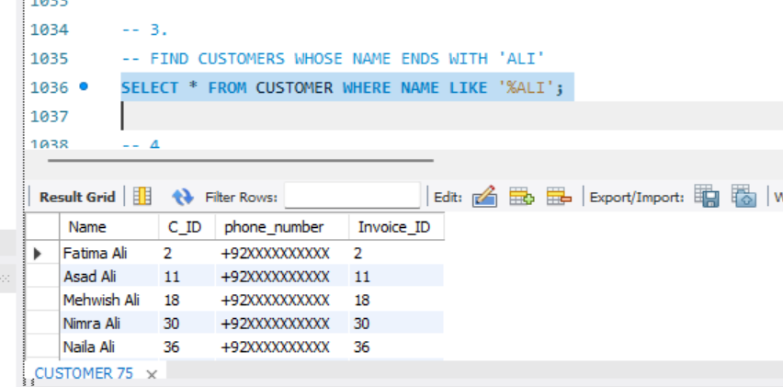

4.
FIND COMPANIES WITH "CARE" IN THEIR NAME
SELECT * FROM MEDICAL_COMPANY WHERE MC_NAME LIKE '%CARE%';
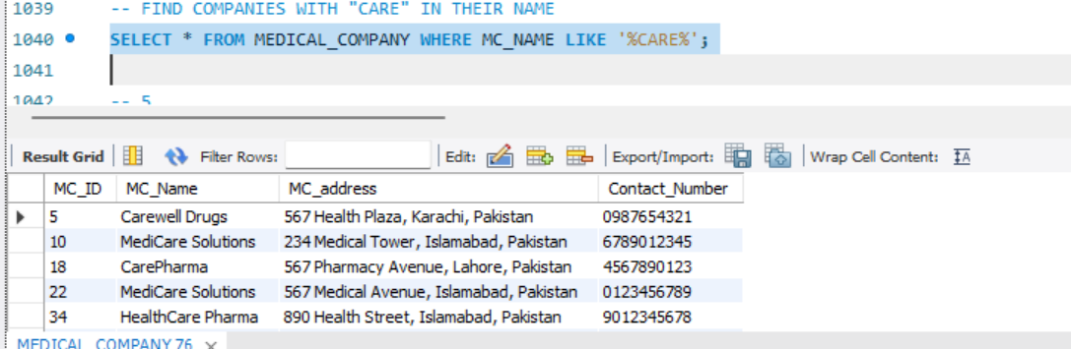

5.
FIND SUPPLIERS WHOSE NAME IS EXACTLY 5 CHARACTERS
SELECT * FROM SUPPLIER WHERE NAME LIKE '_____';

